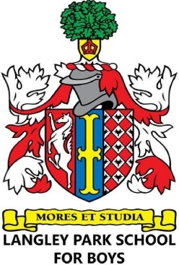
CATEGORY 3 FORM CHILDREN OF STAFF MEMBERS
Please carefully read the School's Admission Policy, which is published on the School's website and available in hard copy form from the School's main office, before completing this form.

If parents are unsure whether their employment status meets the criteria, they should speak to their HR Manager before completing this form.

Child's full legal name:
Child's date of birth:
Child's home address (as defined in the Admission Policy):

Does your child meet the criteria for inclusion in Category 3 - Children of Staff Members employed by Impact Multi Academy Trust at Langley Park School for Boys?  (Please refer to the Admission Policy for the definition of 'staff members' and 'children of a staff members', along with other requirements, before answering) | Yes
 | No
If the answer to the above question is 'Yes', the employed parent must complete the sections below and give their own details. If 'No', either parent's details can be provided. Details of only one parent must be given however.

Parent's full legal name:
Parent's address (if different to above):
Name of school parent is employed at:

I certify that the information that provided in this form is true and accurate, to the best of my knowledge and belief:
Signed:
Dated:

Please note, this form is not an application for admission. A separate application for admission must be made in the usual way using the home Local Authority's Common Application Form (in the normal admission round to Year 7) or London Borough of Bromley's Secondary In-Year Application Form (at all other times to Years 7 to 11).

Please complete and submit this form and submit it with your application ahead of the closing deadline

